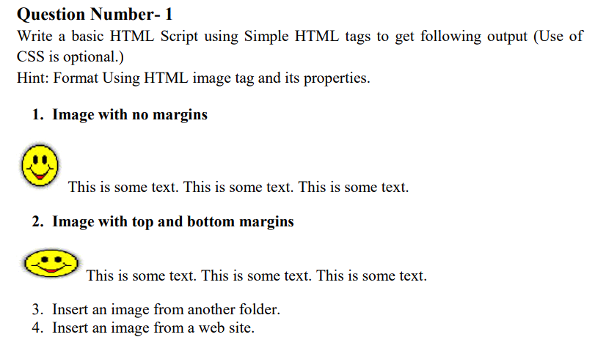
HTML Code

<img src="th.jpeg" alt="Image without margins">

<img src="th.jpeg" alt="Image with top and bottom margins" style="margin-top: 10px; margin-bottom: 10px;">

<img src="th.jpeg" alt="Image from another folder">

<img src="th.jpeg" alt="Image from a web site">

